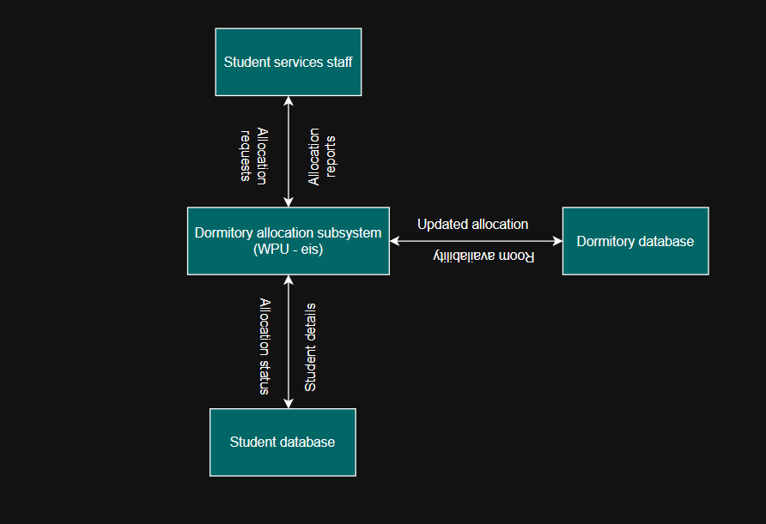

Western Pacific University Enterprise Information System
Dormitory Allocation Subsystem
Major Project Report
IS403
NAME: Naptalai NAKRA
LECTURER: Mr. Cletus
DATE: 23/04/26

Table of Contents
Introduction 2
Project Name 2
Project Description 3
Sponsor Contact 3
Planning Phase 3
Planning Phase Description 3
Define the problem 3
System Vision Document 3
Context Diagram 4
Producing the schedule 5
Work Break Structure (WBS) 5
Gant Chart 5
Staff the Project 5
Organizational Chart 5
Project Responsibilities 6
Analysis Phase 6
Analysis Phase Description 6
Determining System Requirements 6
Interviewees 6
Interview Questions 6
Level – 0 Data Flow Diagram 7
Level -1 Data Flow Diagram 7
Use Case Diagram 8
Entity Relationship Diagram 9
Design Phase 10
Design Phase Description 10
System Architecture 10
User Interfaces 11
Input 11
Output 11
System Interfaces 12
Conclusion 12
Appendices 12
Assumptions 12
Glossary 12

Introduction

Project Name
Western Pacific University Enterprise Information System (WEPU-EIS)
(Dormitory Allocation Subsystem)

Project Description
The Dormitory Allocation Subsystem is part of the Western Pacific University Enterprise Information System. This subsystem is designed to manage student accommodation efficiently by allowing student services staff to view available rooms and dormitories, allocate students to rooms, and monitor occupancy.
Currently, dormitory allocation is handled manually, making it difficult to track room availability and student accommodation records. The proposed subsystem will automate the allocation process and improve efficiency and accuracy.

Sponsor Contact
Organization: Western Pacific University
Department: Student Services
Contact Person: Student Services Director
Email: studentservices@wpu.ac.pg
Phone: +675 75340010

Planning Phase

Planning Phase Description
The planning phase identifies the problem, defines the system scope, and establishes project objectives. This phase ensures that all stakeholders understand the purpose of the dormitory allocation subsystem.

Define the problem
Currently, dormitory allocation at Western Pacific University is performed manually. Student services staff track room availability using paper records or spreadsheets. This process is inefficient and prone to errors, such as double allocation and difficulty in tracking available rooms.
The University requires an automated dormitory allocation subsystem that will allow staff to manage accommodation effectively.

System Vision Document
Problem Description
The current dormitory allocation is manual and inefficient, causing delays and errors.
System Capabilities
The dormitory allocation subsystem will:
- View available dormitories
- View available rooms
- Allocate students to rooms
- View students in dormitories
- Update allocations
- Remove allocations
Business benefits
- Improve efficiency
- Real-time room availability
- Reduced manual errors
- Improved tracking

Context Diagram
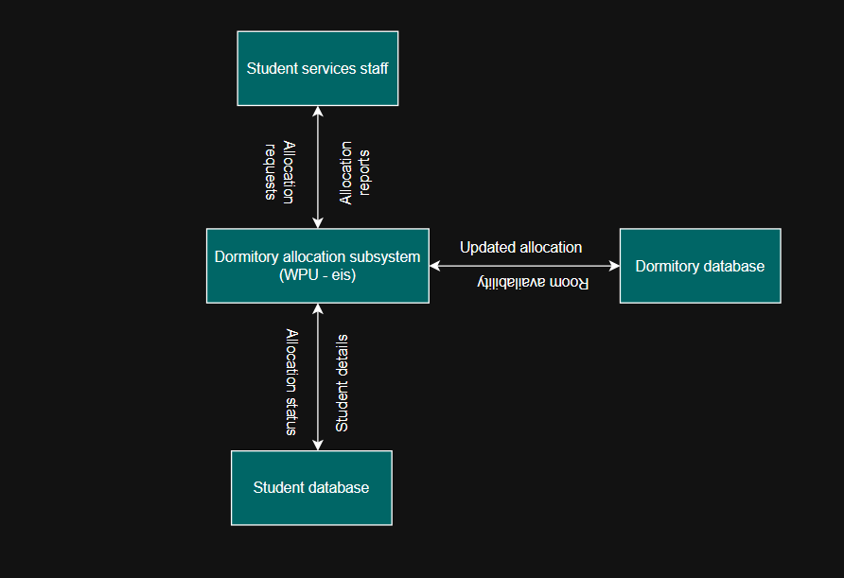

The context diagram represents the dormitory allocation subsystem as a single high-level process and illustrates its interactions with external entities.
The primary external entity is the student services staff, who interact with the system by sending allocation requests and receiving allocation reports.
The subsystem also interacts with external data sources, including the student database and dormitory database. The system retrieves student details and room availability information and updates allocation records after processing.
This diagram provides a high-level overview of how information flows between the system and its environment without showing internal system details.

Producing the schedule

Work Break Structure (WBS)
- Planning Phase
- Analysis Phase
- Design Phase
- Documentation Phase

Gant Chart
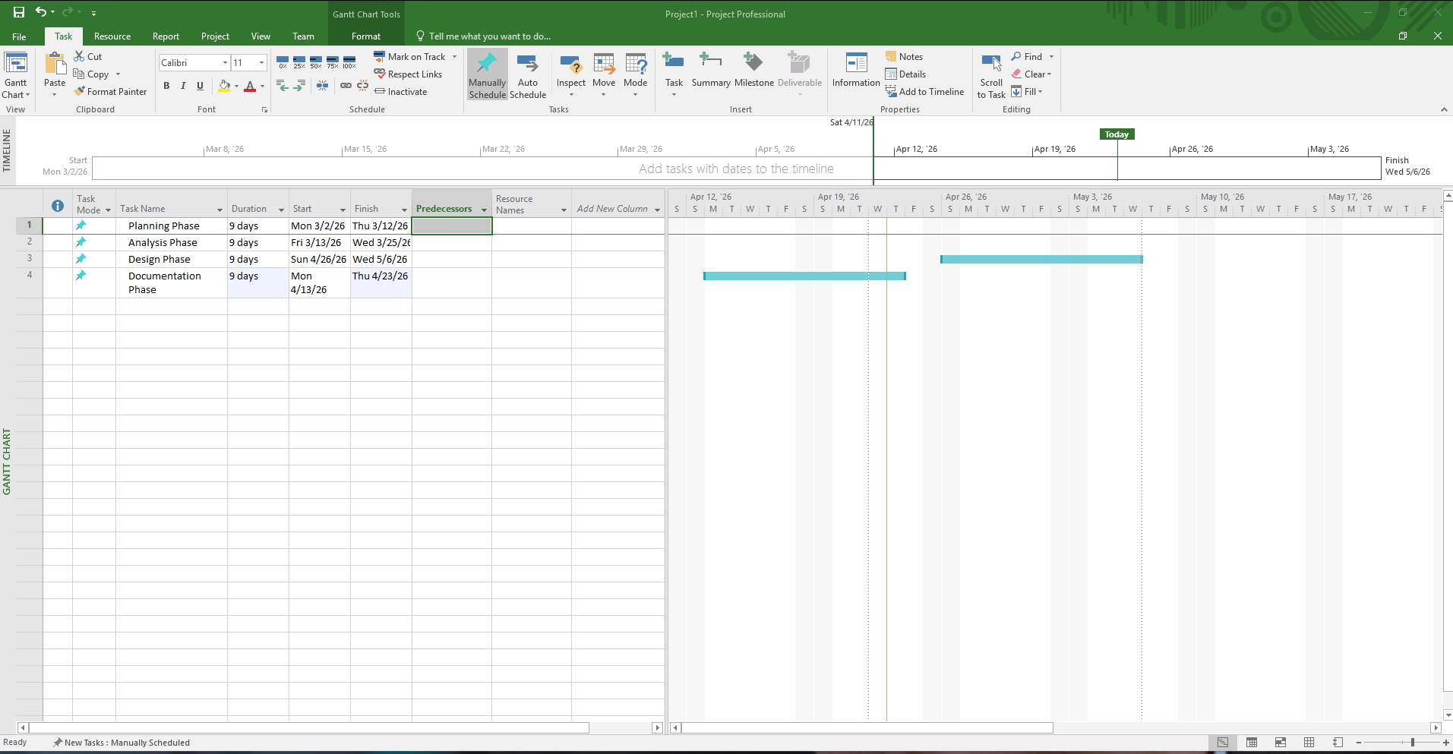

Staff the Project

Organizational Chart
Project Manager
System Analyst
Database Designer
Developer
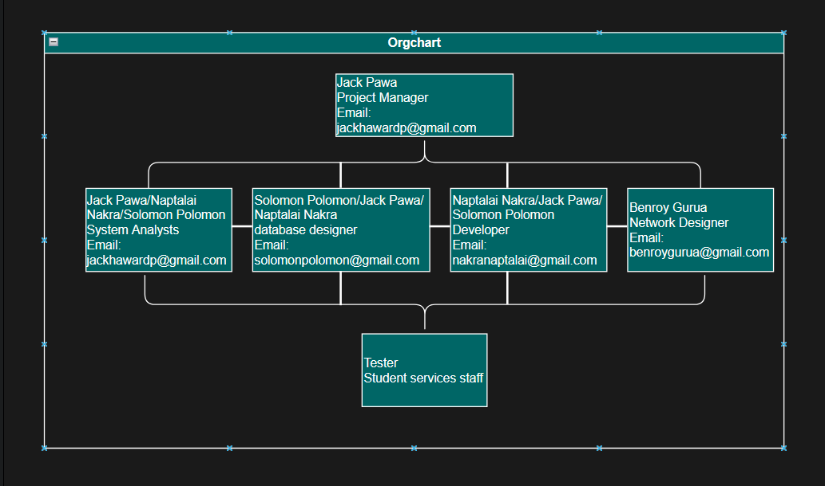

Project Responsibilities
Project Manager – Oversees the project
System Analyst – Gather requirements
Database Designer – Design a database
Developer – Develop subsystem

Analysis Phase

Analysis Phase Description
The analysis phase defines system requirements and creates system models.

Determining System Requirements

Interviewees
- Student services staff
- Registrar staff
- Students
- IT Administrator

Interview Questions
- How is dormitory allocation done currently?
- What problems are faced?
- What features are required?
Expected responses
Manual allocation cause delays and errors. Staff require automated allocation.
  - Requirements Analysis

Level – 0 Data Flow Diagram
Student services –> Allocate student –> System
System –> Update allocation –> Database
Database –> Room availability ––> System
System ––> Report ––> Student services
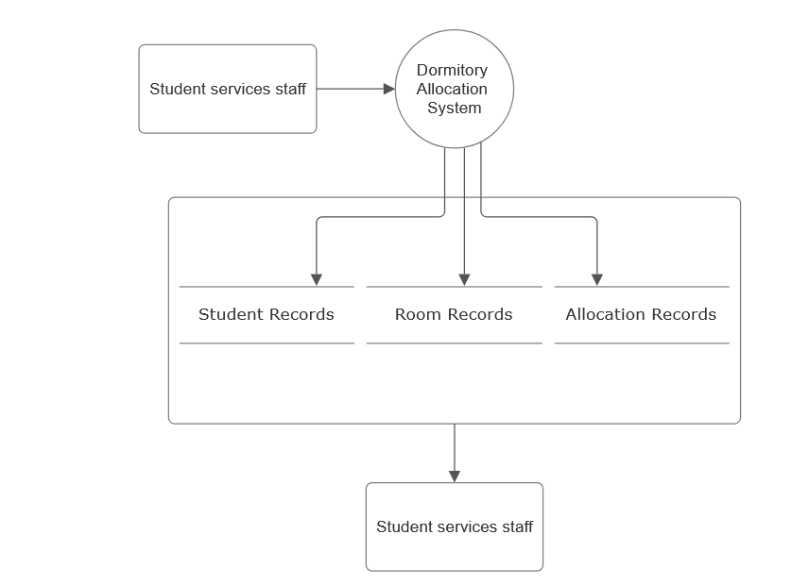
Allocation Requests
Allocation Report

Level -1 Data Flow Diagram
View rooms
Select student
Allocate rooms
Update database
Generate report
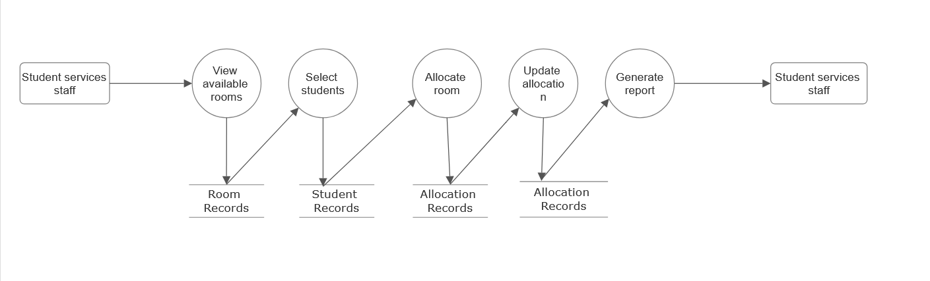
Allocation report
Allocation date
Student Info
Room data
Request

Use Case Diagram
Actor: Student services staff
Use cases:
- View dormitories
- View rooms
- Allocate students
- Update allocations
- Remove allocation
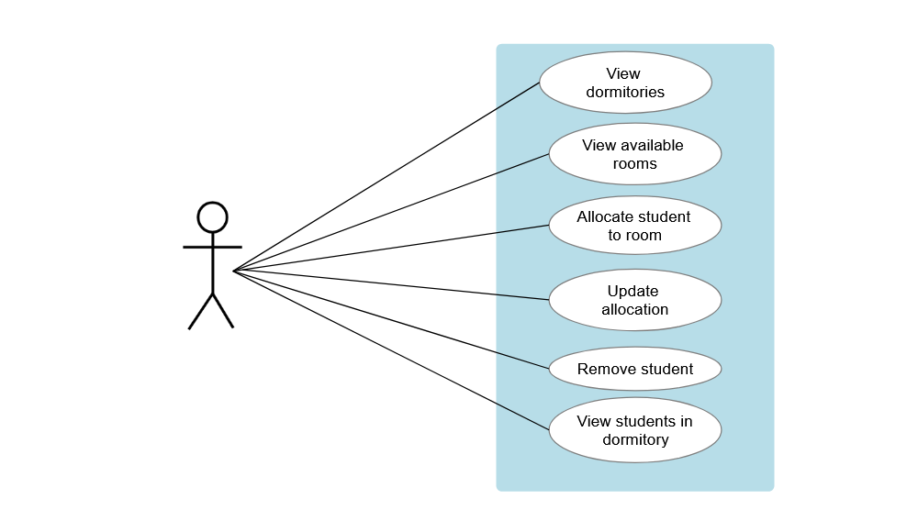
Student services staff

Entity Relationship Diagram
Entities:
- Student
- Dormitory
- Room
- Floor
- Allocation
Relationship:
- Student allocated to room
- Room located in a dormitory
- Floors located in the dormitory
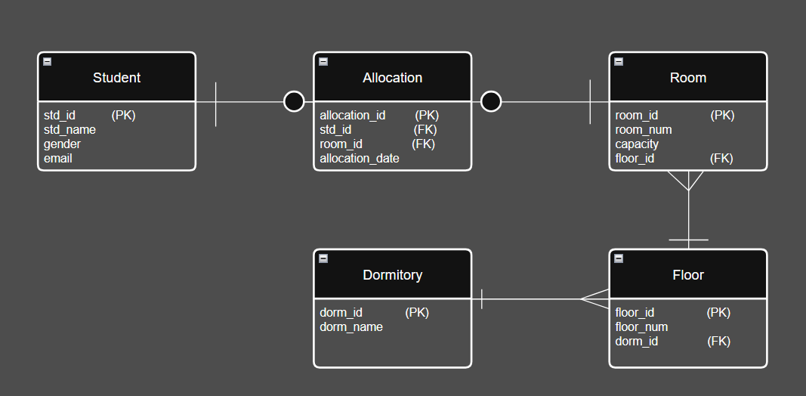

Design Phase

Design Phase Description
The design phase describes system architecture and interfaces.

System Architecture
Three Tier Architecture
- Presentation Layer
This is the front-end of the system where users interact with the application
In this subsystem:
- Used by student services staff
- Accessible through:
- Web browser (Chrome, Edge, etc.)
- University portal/dashboard
Functions:
- Display available dormitories and rooms
- Provide forms to allocate students
- Allow updating or removing allocations
- Show reports (room availability, student accommodations)
- Example: a staff member logs in and sees a list of available rooms, then selects a student and assigns them to a room.
- Application Layer (Business Logic Layer)
This is the brain of the system where all processing and decision-making occur. It handles dormitory allocation logic.
Functions:
- Check room availability
- Ensure no room is over-allocated
- Validate student eligibility
- Process allocation requests
- Update allocation records
- Generate reports
- Example:
When a staff member selects a room:
- The system checks to see if the room is full
- If available, it allows allocation
- If not, shows an error message

- Database Layer (Data Layer)
This layer stores and manages all the system’s data. It stores dormitory-related data.
Data stored:
- Student details
- Dormitory details
- Floor and room information
- Allocation records
Tables used:
- Student
- Dormitory
- Room
- Floor
- Allocation
Functions
- Store new allocations
- Retrieve room availability
- Maintained data consistency
- Support reporting

User Interfaces

Input
- Allocate room form
- View room form
- Update allocation form

Output
- Dormitory allocation report
- Room availability report

System Interfaces
- Shared database
- Authentication system

Conclusion
The dormitory allocation subsystem provides an efficient and structured solution to the challenges currently faced by Western Pacific University in managing student accommodation. By replacing manual processes with an automated system, the subsystem improves accuracy, reduces administrative workload, and enables real-time tracking of room availability and student allocations.
Through the planning, analysis, and design phases, the subsystem has been carefully developed to meet the needs of student services staff while ensuring integration with the overall enterprise system. The use of a centralized database, clear system architecture, and well-defined data models ensures scalability and reliability for future expansion.

Appendices

Assumptions
- Dormitories exist
- Students eligible for dorms
- Staff have access

Glossary
- Dormitory – students' accommodation building
- Allocation – assigning students to a room
- Subsystem – part of the main system
- Authentication – the process of verifying a user’s identity using login credentials such as email and password.
- Authorization – the process of granting access rights to users based on their role (e.g., Student Services staff).
- Database – a structured collection of data stored electronically, used to manage student, dormitory, and allocation records.
- Entity – an object or concept in the system that can store data, such as a student, room, or dormitory.
- Entity Relationship Diagram (ERD) – a diagram that shows a relationship between entities in a database.
- Foreign key – a field in a table that links to the primary key of another table to create relationships
- Primary key – a unique identifier for each record in a database table (e.g., STUDENT_id).

